Customization of TaxNow

The client in this example has the following customizations

* Two custom addresses added to their Opportunities as follows:
  + Ship_To Address = default shipto
  + Service Address = secondary if shipto is blank
* Custom Field, ESB which is to be used as CompanyCode
* Custom Field, Tax Exempt, which is a Yes/No dropdown

Steps to support these customizations:

1. Add a new Apex Class “CustomOppGetTax” extends AFA_SFCORE.GetTaxOpportunity to override FetchDestinationAddress and FetchTaxData
   1. Former pulls address from ship_to unless use billing address is specified, then uses Service address
   2. Latter honors CompanyCode = EBS
   3. Latter honors Tax Exempt drop down => if Yes exempts from tax
2. Add a new VFPage, CustomOppGetTaxHandler which is a clone of OppGetTaxHandler, but replaces the extension class AVA_SFCORE.GetTaxOpportunity with CustomOppGetTaxHandler
3. Added a new Button CustomOppGetTax which is linked to CustomOppGetTaxHandler
4. 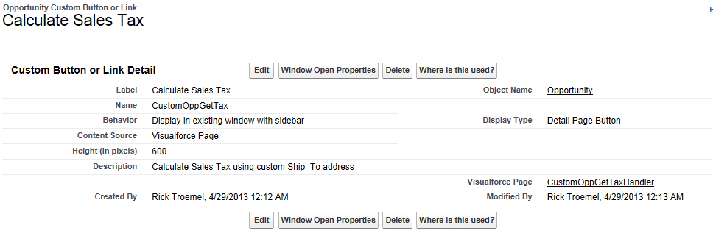
5. Add a new VFPage, CustomOppFinalizeHandler, which is a clone of Opp_Finalize_Handler with CustomOppGetTaxHandler relacing the extension class
6. Add a new Button CustomOppFinalize which is linked to CustomOppFinalizeHandler
   1. 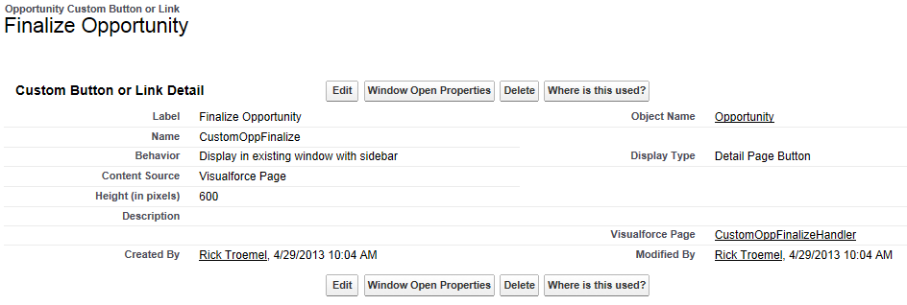
7. Replace old Calculate Tax button with new Custom OppGetTax, and old Finalize Button with new CustomOppFinalize in page layouts